Lighthouse Specialty Plate Pre-Order Form
(Order Online @ www.MaineLighthouseTrust.org)
Name
_{First} _{Last}
Address
_{Street}
Address
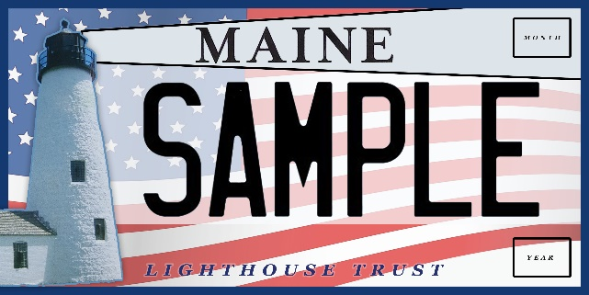
City State
Address
_{Zip Code}
Phone #

Current
Registration

Email

Signature
By signing above you agree to swap your current Maine registration plate with the new Maine Lighthouse plate.
Founders
Campaign
Enter your affiliated organization
Please send $25 check to: Maine Lighthouse Trust
P.O. Box 16
Biddeford Pool, ME 04006

